| **CSIC30100: Brain Computer Interface** | **(Due: 06/02/2023)** |
| --- | --- |
| Term-project: Motor Imagery Classification | |
| Instructor: Chun-Shu Wei  TA: | Student Id |

## **Introduction**

Similar to homework 3, you will be working on Motor Imagery classification using deep learning. In this term-project, you will need to select a paper from the candidate list and reproduce the results including data preprocessing on the provided unprocessed BCIC-IV 2a dataset, implementing the proposed model in the paper, and finally compare its performance with the 3 baseline models in HW3. Each group will have to give a presentation to show your works.

[BCIC IV 2a Dataset](https://drive.google.com/drive/folders/1rIJBrWK6tVc2Hjh2umnAjCUx-J6vUJrc?usp=share_link)

[Paper candidates](https://docs.google.com/spreadsheets/u/2/d/1-Lrtx7YKbvoogXuo5VEqL4ey1et187R67CUQoMeizNc/edit)

## **Submission policy**

* Each group needs to submit 1 **technical report** (.pdf), **source codes** (.py or .ipynb) and **slides** for presentation (ppt or pdf) and wrap them up into a .zip file.
* Implementation will be graded by completeness, algorithm correctness, model description, and your discussion.
* All codes used to obtain the results should be packed and must contain comments for explanation. Only Python is allowed.
* Please name all your files as final_group{GroupNumber}. For example, final_group7.zip, final_group7.pdf, and so on. Illegal format penalty: **-5 points** for violating each rule of formats.
* Using released code from authors or other implementations available online is allowed, but the source should be listed in both code comments and reports. (The code explanation comments should still be done on your own.)
* Late submission penalty: **original score*0.8** within a week
* Submission deadline: **2023.06.03 00:00 AM**.

## **Requirements**

* **Reproduction** 
  + Follow the paper to reproduce the studies in the paper (data preprocessing, model implementation, etc)

(Hint: Even if the preprocessing in paper is done on EEGLAB, MNE package is allowed)

* + Use the training and validation schemes described in their work and try to reproduce the results.
  + Using source codes is allowed in the reproduction.
* **Common Validation**

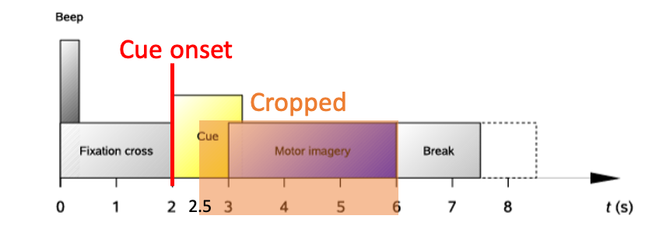

* + Filter the data with [4, 38] bandpass filter.
  + Downsample data to 125 Hz.
  + Crop the data from 0.5 second after cue onset to end of imagination. (2.5 ~6 seconds refer to the timeline). (Hint: Find the event marks for cue onset and use them to crop interval of interest)

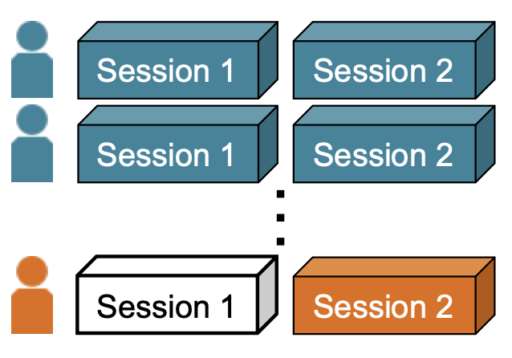

* + Subject Independent training scheme for 9 subjects. (9 models) (This time, we don’t hide any session for evaluation. You use all sessions other than the testing subject as training data)
  + Compare your implementation with three baselines models from hw3. (EEGNet, ShallowConvNet, SCCNet, with a total of 9*3=27 models.)
* **Presentation** (5/26)
  + Your presentation should include but is not limited to
    - Introduction of the research (background, motivations, goals, contribution)
    - Method (pre-processing, proposed model)
    - Experiment setting
    - Your experiment results
    - Your observations and discussion
    - Conclusion or your comments
  + Presentation (15 min) + QA (5 min)
* **Technical report**
  + **Introduction:** Overview of the research, including goal, techniques and contribution.
  + **Baselines:** The baselines must contain 1.EEGNet, 2.ShallowConvNet, 3.SCCNet. You can do your own survey and add more baseline models.
  + **Your implementation:** Describe your method in detail, including the architecture of your model, the training setting, parameter determination, etc.
  + **Experiments:** Compare your implementation with all three baselines using the training schemes in their work as well as the ‘individual’ training schemes (these two may or may not be the same). Statistical analysis is required to validate the performance improvement (e.g. Wilcoxon sign-rank test). Repeats >=10 times may be needed to avoid bias due to randomization.
  + **Discussion:** Discussion may include but is not limited to: 1) the performance comparison between **your implementation** and the **baselines**; 2) the performance of **your implementation** against what has been **reported in the paper**. If the deviation in performance is significant in your replication, try to explain the reasons. 3) Suggestions for future model design for EEG decoding.
  + **Conclusion:** Summary of the findings and significance of your work.